No | DESCRIPTION | SAT | RING 1
A | Service
1 | Pulling FOC ADSS Short Span(includes Cable pulling Services, Accessories, Jointing, OTDR, and Licensing outside Sitac) | M | 26,648
2 | Excavations Towing Garden Soil Trails (Inc. Pegs/Signs, Plant Repair/Asphalt/Sidewalks, Site Tidying) | m | -
3 | Excavation of Towing Route Rojok Alur (Inc. Pegs/Signs, Repair of Plants/Asphalt/Sidewalks, Site Tidying) - FOC 24 core | m | -
4 | Jointing per core | CORE | 480
5 | labeling Joint Box | UNIT | 18
6 | Tracing core (2 core) | CORE
7 | OTDR per core | CORE | 44
8 | Labeling Kabel (1 pole 2 label, special for tidying label) | UNIT | 1,024
9 | Labeling In Site Plan (labeling patch cord, labeling POP device and User) | UNIT | 44
10 | Installation and Commissioning FOT (Switch) (DCU side) | UNIT | 9
11 | Handhole 40x40x40 cm (Permanent) | UNIT | -
12 | Manhole 80x80x100 cm (Permanent) | UNIT | -
13 | Instalasi Joint Box 24 Core (jointing fo per 4,000 meters) | UNIT | 18
B | MATERIAL
1 | Fiber Optics 24 core （ADSS-100M，FOC provided by contractor） | M | 26,648
2 | Fitting Deadend (Inc. Fitting Deadend, Strain clamp, Stop Link, Steel Band, Labeling) | Unit | 515
3 | Fitting Suspension (Inc. Stop Link, Steel Band) | Unit | 398
4 | UTP Cat 5e (FOT to DCU) | M | 27
5 | Connector RJ45 Cat5 | set | 72
6 | Patch Cord Single Mode (SC/UPC-FC, SC/UPC-LC, SC/UPC-SC/UPC, LC-LC, FC-LC) 1 install 5m - DCU or POP side | set | 11
7 | Joint Box 24 Core (jointing fo per 4,000 meters) | Unit | 18
8 | Joint Box 2 Core - Substation |  | -
9 | ODF Rack Mounted 2 Core (tipe SC upc) - DCU Side |  | -
10 | ODF Rack Mounted 24 Core (tipe SC upc) - ODF POP Side | Unit | 2
11 | ODP 2 cores - DCU side ODC (Rowset) | Unit | -
12 | Drop wire 2 cores |  | -
13 | UTP Cat 5e (FOT to DCU) | Unit | -
14 | FOT L3(Minimal 6 Port, by DCU side) | Unit | 9
15 | SFP - single core 1 GB 10 km (link between substations) | Unit | 16
16 | SFP - single core 1 GB 40 km (link between POP-substation/ODC) | Unit | 4
17 | OSP (PVC pipes, Galvanized Pipe, etc., A line-by-line description based on the results of the site survey.)
 | - PVC Pipe 2" | m | -
 | - HDPE 2" (FOC 24 core) | m | -
 | - Galvanize pipe 2" | m | 8
18 | ODF Rack Mounted 2 Core (tipe SC upc) - DCU Side
C | ADDITIONAL ITEMS
1 | SERVICES
1.1 | ODC installation |  | -
1.2 | FOT L3 configuration & commissioning | Unit | 9
1.3 | ODC L3 configuration & commissioning |  | -
2 | MATERIAL
2.1 | ODC -(Out Door Cabinet, by POP side. Used for FO terminals on the POP side, as most POPs do not have enough space for the device.). | Unit | -
2.2 | L3 device (NNI) on ODC to connect from ODC to POP (related item 2.1) - * cores @SFP *core *km | Unit | -
2.3 | OSP (Foundation, Grounding bar/cables/accessories, etc., A line-by-line description based on the results of the site survey.) | Unit | -
5 | Pole 7 m | btg | -
 | Pole 9 m | btg | -
 | Pipa Galpanis 2" | btg | -
 | HDPE 2" | m | -
 | ROSET 6 core DCU | Unit | 9
 | OTB 24 CORE | Unit | -
 | OTB 48 CORE | Unit | -
 | OTB 96 CORE | Unit | -
 | OTB 144 CORE | Unit | -
 | PATCHCORD (LC-SC) 5M | Unit | -
 | PIGTAIL LC | Unit | -
 | ATTNUATOR 10 db (Peredam) | Unit | -
 | ODC 3 KABIN | Unit | -
 | Joint Box 48 Core (jointing fo per 4,000 meters) | Unit | -
 | Joint Box 144 Core (jointing fo per 4,000 meters) | Unit | -
 | RK | Unit | -
D | Transportation
1 | Material Transportation |  | 1
2 | ------

 |  |  | 1.01 | DRUMPLAN RING 1 - BUS 1
NOMER POLE | SPAN (m) | PANJANG KUMULATIF (m) | TITIK JOINT BOX | TYPE FITTING |  |  | TYPRE FITTING TIANG |  | KOORDINAT TIANG | TYPE POLE |  | POTENSI GALIAN | POSISI TIANG
 |  |  |  | DE (A) | SUSP (D) | CRNA COIL | A | D
 |  |  |  |  |  |  | 100 | 100 | KOORDINAT TIANG | NEW | EXISTING | POTENSI GALIAN | POSISI TIANG
POP |  | 0 |  | A |  |  | 2 |  | S6 09.187 E106 34.176 | - | 1 | -
1 | 13 | 13 |  | A |  |  | 2 |  | S6 09.194 E106 34.176 | - | 1 | -
2 | 19 | 32 |  |  | D |  |  | 1 | S6 09.196 E106 34.166 | - | 1 | -
3 | 27 | 60 |  |  | D |  |  | 1 | S6 09.199 E106 34.151 | - | 1 | -
4 | 35 | 95 |  | A |  |  | 2 |  | S6 09.203 E106 34.133 | - | 1 | -
5 | 36 | 131 |  |  | D |  |  | 1 | S6 09.206 E106 34.113 | - | 1 | -
6 | 34 | 166 |  |  | D |  |  | 1 | S6 09.209 E106 34.095 | - | 1 | -
7 | 36 | 202 |  | A |  |  | 2 |  | S6 09.212 E106 34.076 | - | 1 | -
8 | 35 | 237 |  |  | D |  |  | 1 | S6 09.216 E106 34.057 | - | 1 | -
9 | 30 | 268 |  |  | D |  |  | 1 | S6 09.200 E106 34.053 | - | 1 | -
10 | 34 | 302 |  |  | D |  |  | 1 | S6 09.182 E106 34.049 | - | 1 | -
11 | 34 | 336 |  | A |  |  | 2 |  | S6 09.164 E106 34.047 | - | 1 | -
12 | 31 | 368 |  |  | D |  |  | 1 | S6 09.148 E106 34.045 | - | 1 | -
13 | 30 | 398 |  |  | D |  |  | 1 | S6 09.132 E106 34.043 | - | 1 | -
14 | 24 | 422 |  |  | D |  |  | 1 | S6 09.133 E106 34.030 | - | 1 | -
15 | 29 | 451 |  | A |  |  | 2 |  | S6 09.136 E106 34.015 | - | 1 | -
16 | 25 | 477 |  |  | D |  |  | 1 | S6 09.149 E106 34.016 | - | 1 | -
17 | 28 | 505 |  |  | D |  |  | 1 | S6 09.164 E106 34.018 | - | 1 | -
18 | 29 | 534 |  | A |  |  | 2 |  | S6 09.180 E106 34.020 | - | 1 | -
19 | 27 | 562 |  |  | D |  |  | 1 | S6 09.194 E106 34.022 | - | 1 | -
20 | 32 | 594 | JB SPARE | A |  |  | 2 |  | S6 09.211 E106 34.025 | - | 1 | -
21 | 26 | 620 |  | A |  |  | 2 |  | S6 09.225 E106 34.027 | - | 1 | -
22 | 30 | 650 |  |  | D |  |  | 1 | S6 09.241 E106 34.029 | - | 1 | -
23 | 27 | 678 |  |  | D |  |  | 1 | S6 09.253 E106 34.037 | - | 1 | -
24 | 24 | 702 |  |  | D |  |  | 1 | S6 09.264 E106 34.044 | - | 1 | -
25 | 29 | 731 |  | A |  |  | 2 |  | S6 09.276 E106 34.054 | - | 1 | -

 |  |  | 1.01 | DRUMPLAN RING 1 BUS 4
NOMER POLE | SPAN (m) | PANJANG KUMULATIF (m) | TITIK JOINT BOX | TYPE FITTING |  |  | TYPRE FITTING TIANG |  | KOORDINAT TIANG | TYOE POLE |  | POTENSI GALIAN | POSISI TIANG
 |  |  |  | DE (A) | SUSP (D) | CRNA COIL | A | D
 |  |  |  |  |  |  | 100 | 100 | KOORDINAT TIANG | NEW | EXISTING | POTENSI GALIAN | POSISI TIANG
POP |  | 0 |  |  |  |  |  |  | S6 12.280 E106 31.347 | - | 1 | -
1 | 24 | 24 |  | A |  |  | 2 |  | S6 12.279 E106 31.335 | - | 1 | -
2 | 30 | 55 |  |  | D |  |  | 1 | S6 12.263 E106 31.335 | - | 1 | -
3 | 30 | 85 |  |  | D |  |  | 1 | S6 12.247 E106 31.335 | - | 1 | -
4 | 30 | 115 |  | A |  |  | 2 |  | S6 12.231 E106 31.338 | - | 1 | -
5 | 34 | 149 |  |  | D |  |  | 1 | S6 12.214 E106 31.343 | - | 1 | -
6 | 36 | 186 |  |  | D |  |  | 1 | S6 12.195 E106 31.348 | - | 1 | -
7 | 41 | 227 |  |  | D |  |  | 1 | S6 12.174 E106 31.355 | - | 1 | -
8 | 45 | 273 |  | A |  |  | 2 |  | S6 12.151 E106 31.362 | - | 1 | -
9 | 45 | 318 |  |  | D |  |  | 1 | S6 12.129 E106 31.372 | - | 1 | -
10 | 49 | 368 |  |  | D |  |  | 1 | S6 12.106 E106 31.385 | - | 1 | -
11 | 49 | 417 |  |  | D |  |  | 1 | S6 12.083 E106 31.398 | - | 1 | -
12 | 47 | 465 |  | A |  |  | 2 |  | S6 12.061 E106 31.411 | - | 1 | -
13 | 49 | 514 |  |  | D |  |  | 1 | S6 12.041 E106 31.429 | - | 1 | -
14 | 53 | 568 |  |  | D |  |  | 1 | S6 12.022 E106 31.451 | - | 1 | -
15 | 50 | 618 |  |  | D |  |  | 1 | S6 12.012 E106 31.476 | - | 1 | -
16 | 54 | 673 |  | A |  |  | 2 |  | S6 12.002 E106 31.503 | - | 1 | -
17 | 55 | 728 |  |  | D |  |  | 1 | S6 11.983 E106 31.527 | - | 1 | -
18 | 51 | 780 |  |  | D |  |  | 1 | S6 11.966 E106 31.548 | - | 1 | -
19 | 50 | 830 |  | A |  |  | 2 |  | S6 11.943 E106 31.562 | - | 1 | -
20 | 52 | 883 |  |  | D |  |  | 1 | S6 11.919 E106 31.577 | - | 1 | -
21 | 53 | 936 |  | A |  |  | 2 |  | S6 11.897 E106 31.596 | - | 1 | -
22 | 56 | 993 |  |  | D |  |  | 1 | S6 11.868 E106 31.603 | - | 1 | -
23 | 50 | 1043 |  |  | D |  |  | 1 | S6 11.841 E106 31.607 | - | 1 | -
24 | 52 | 1096 |  | A |  |  | 2 |  | S6 11.815 E106 31.617 | - | 1 | -
25 | 39 | 1135 | JB SPARE | A |  |  | 2 |  | S6 11.795 E106 31.623 | - | 1 | -
26 | 46 | 1182 |  |  | D |  |  | 1 | S6 11.771 E106 31.630 | - | 1 | -

BUS 1
jumlah | satuan | accessories | CLUSTER | GARDU
9 | Pics | Joint box
11,315 | Meter | Cable
2 | Roll | Stelband
242 | Set | Dead end clamp
185 | Set | Suspension
3 | HASPEL | ADSS 24C
 |  |  | 5 | 5
BUS 4
jumlah | satuan | ACCESSPRIES | CLUSTER | GARDU
9 | Pics | Joint box
15789 | Meter | Cable
2 | Roll | Stelband
286 | Set | Dead end clamp
214 | Set | Suspension
4 | HASPEL | ADSS 24C
 |  |  | 4 | 4

FIBER OPTIC CABLE DRUM PLAN

Material Fitting dan Accessories Installation :(for reference only)

1 | Fitting Tension 600 | 0 set
2 | Fitting Tension 900 | 0 set
3 | Fitting Suspension 600 | 0 set
4 | Fitting Suspension 900 | 0 set
5 | Vibration Damper 600 | 0 buah
6 | Vibration Damper 900 | 0 buah
7 | Fitting Dead End Short Span | 0 set
8 | OTB 24F | 0 unit
9 | ODF 24F | 2 unit
10 | OGB 24F | 0 unit
11 | Joint Box (JB) 24F | 18 unit
12 | Fitmen Tension Type H | 512 set
13 | Fitmen Suspension Type I | 393 set
14 | Klem U-Bolt Double Plat | 0 buah (Untuk Gantry atas)

DRUM SCHEDULE KABEL ADSS
Drum ADSS No : | Identification | Length (m)
 |  | 26,648
Jumlah Panjang Kabel yang dibutuhkan :

DRUM SCHEDULE KABEL FA
Drum FA No : | Identification | Length (m)
Jumlah Panjang Kabel yang dibutuhkan :
Drum FA No : | Identification | Length (m)

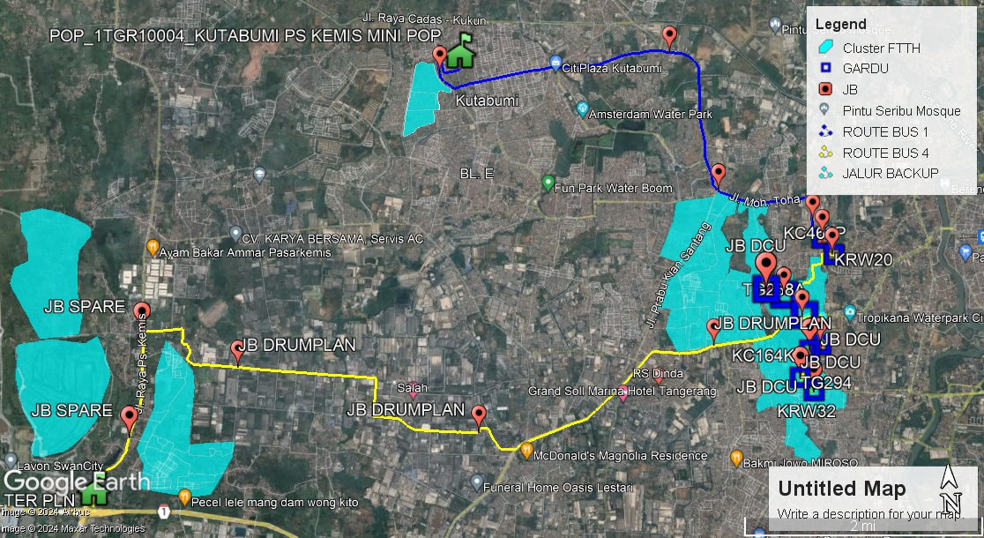
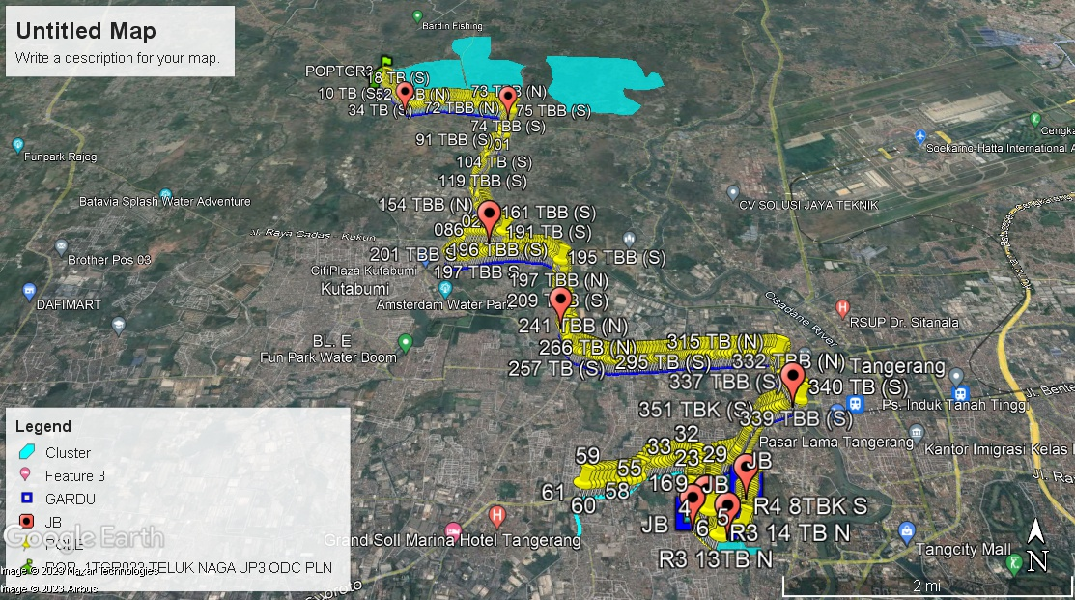

BUS 1
POP TO KC462P. TRACK LENGTH : 8,4 KM

KC462P TO KRW30. TRACK LENGTH : 351 M

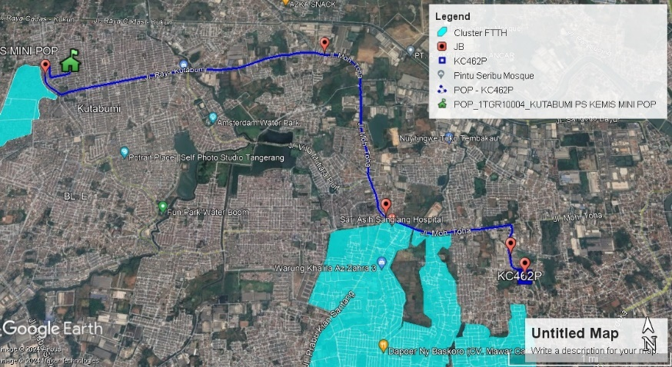
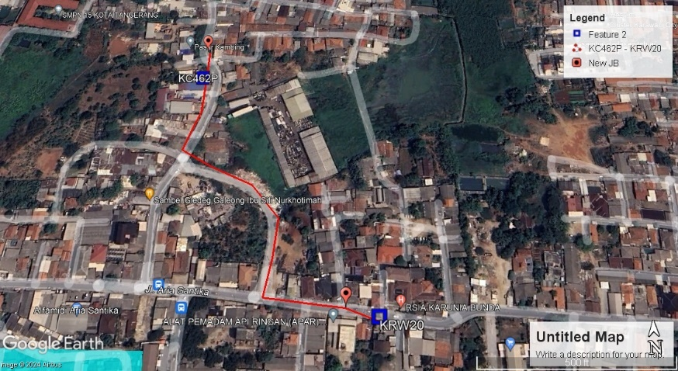

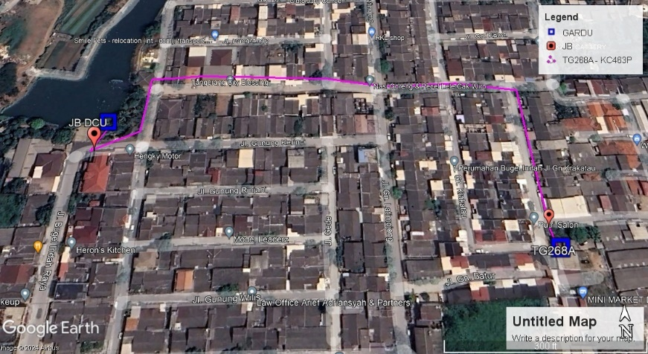
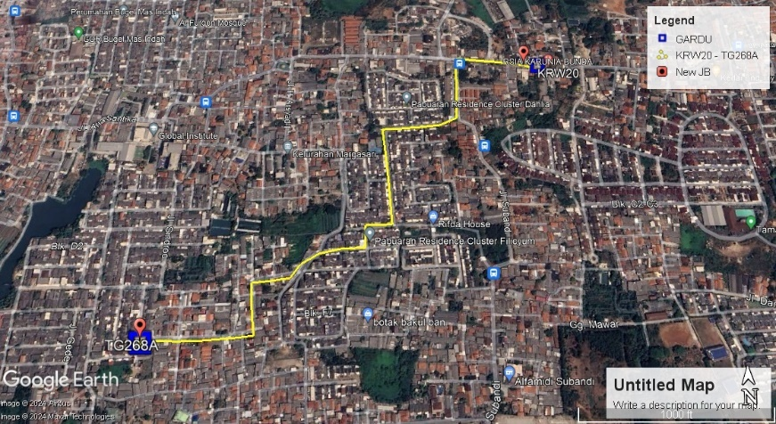
TG268A TO KC463P TRACK LENGTH : 404 M

KRW30 TO TG268A TRACK LENGTH : 1,2 KM

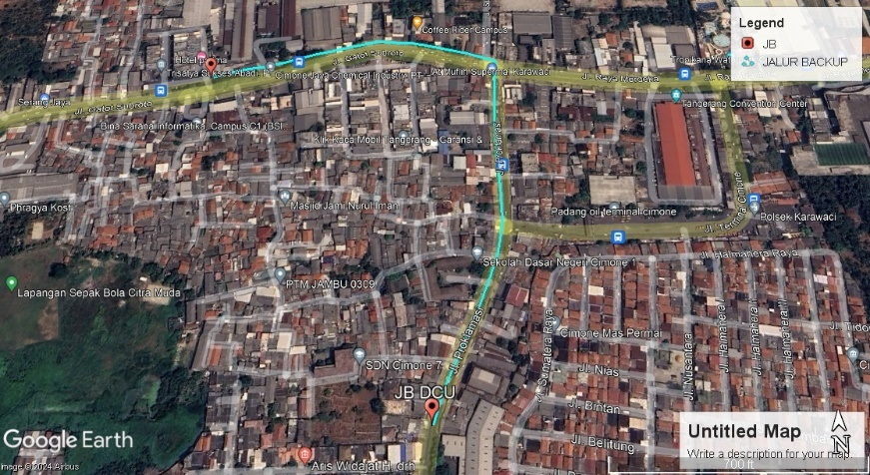
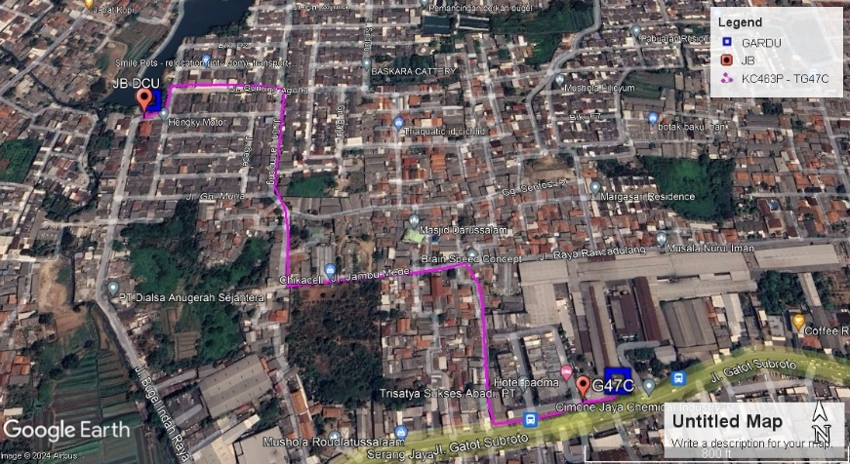
KC463P TO TG47C TRACK LENGTH : 987 M

JALUR BACKUP. TRACK LENGTH : 742 M

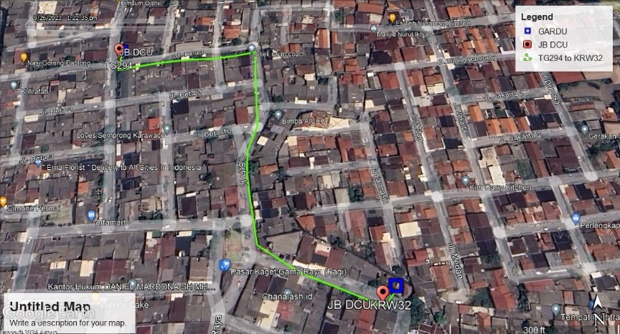
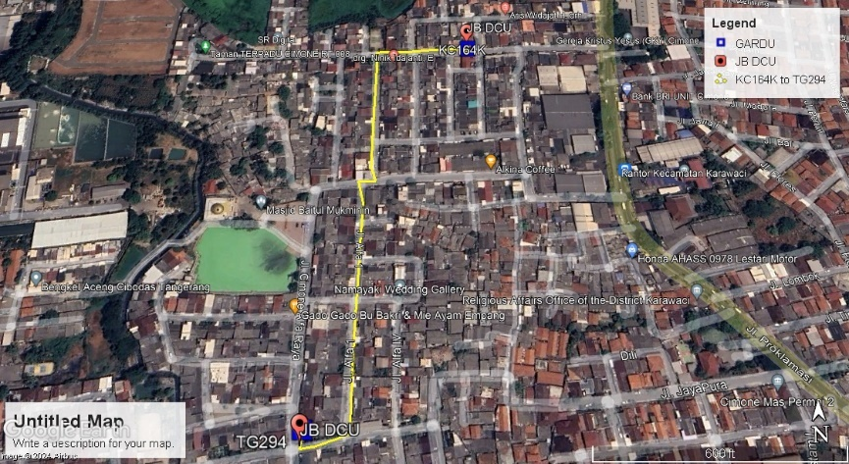
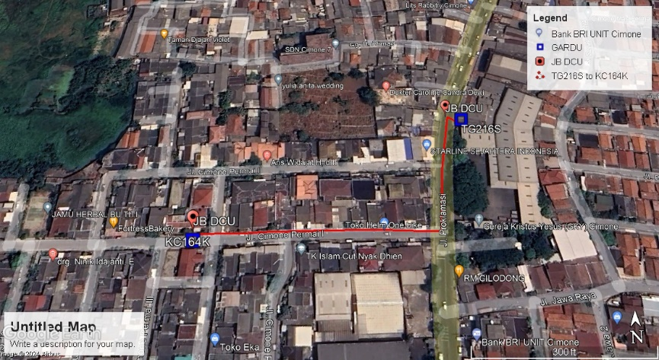
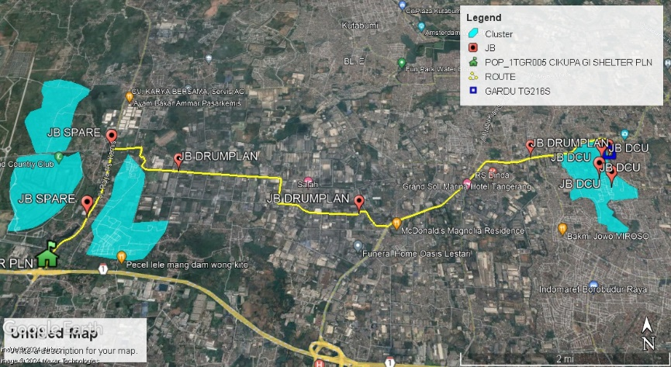
BUS 4
KC164K TO TG294. TRACK LENGTH : 526 M

TG216S TO KC164K. TRACK LENGTH : 228 M

TG294 TO KRW32. TRACK LENGTH : 363 M

POP TO TG216S. TRACK LENGTH : 14,1 KM

BUS 1
GARDU KC462P
S6 10.567 E106 36.803

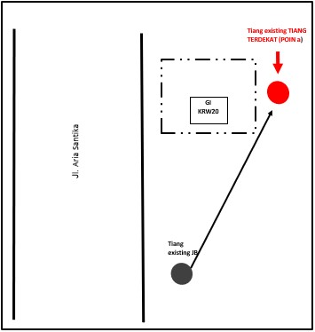
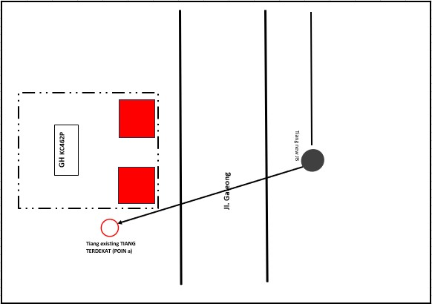
GARDU KRW20
S6 10.692 E106 36.885
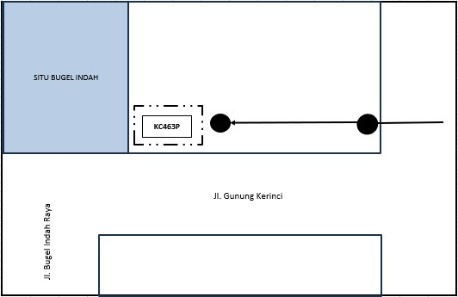
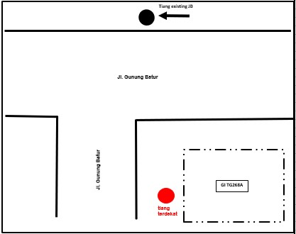
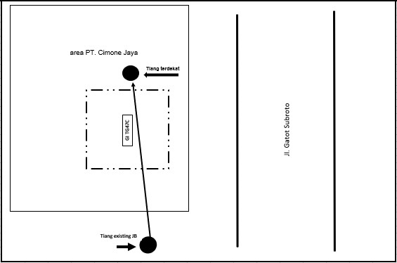
GARDU KC463P
S6 10.923 E106 36.370
GARDU TG268A
S6 10.971 E106 36.498
GARDU TG47C
S6 11.127 E106 36.642

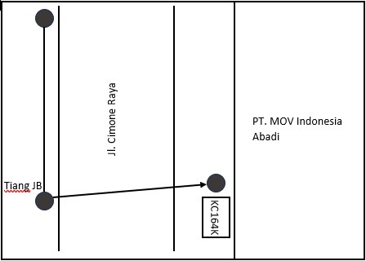
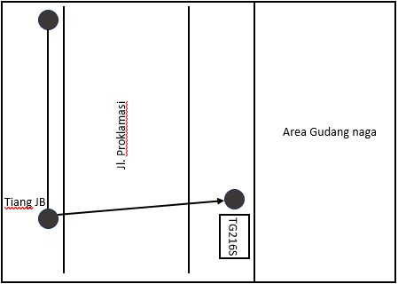
BUS 4
GARDU TG216S
S6 11.348 E106 36.750
GARDU KC164K
S6 11.386 E106 36.665

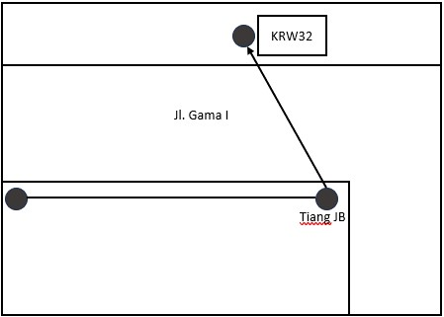
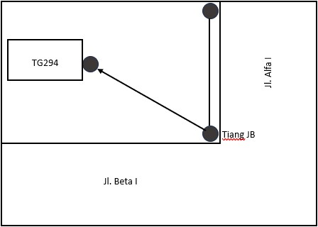
GARDU KRW32
S6 11.683 E106 36.682
GARDU TG294
S6 11.581 E106 36.584

POP BUS 1

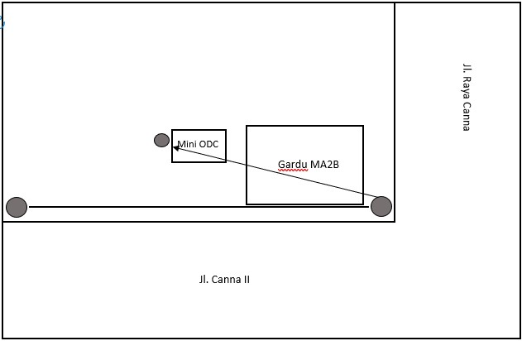

POP BUS 4

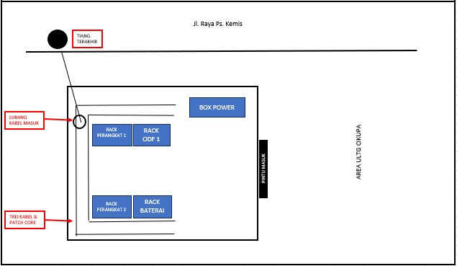

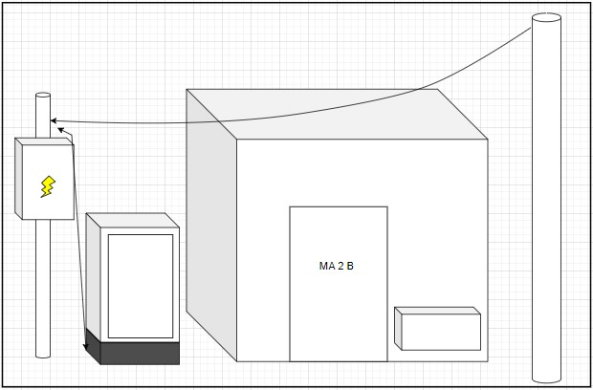
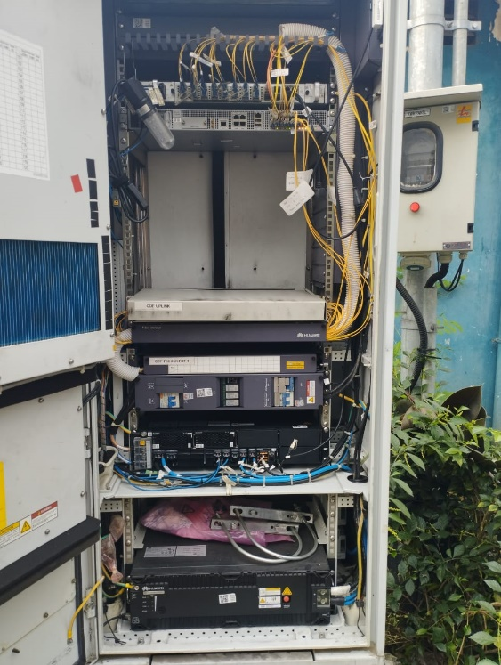

POP_1TGR005 CIKUPA GI SHELTER PLN
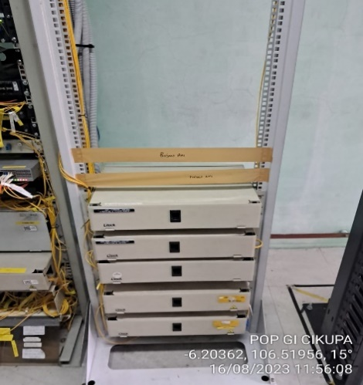
(POP BUS 4)

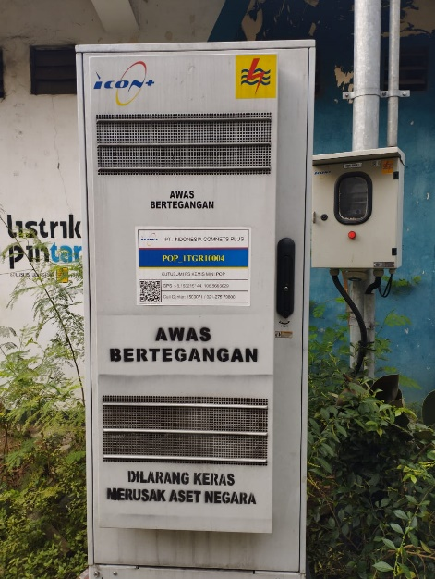 | 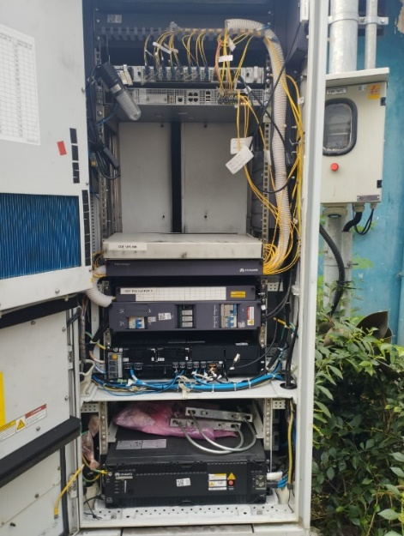  BUS 1 | 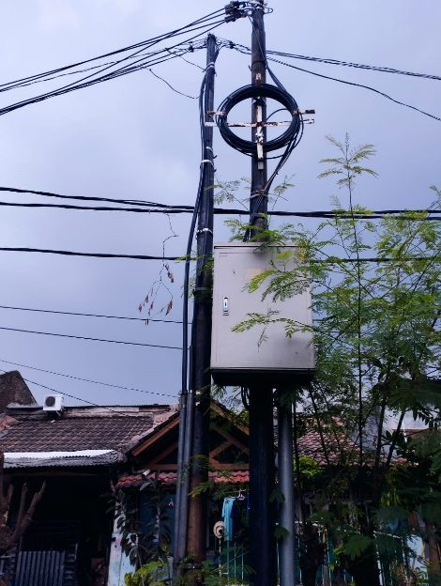 | 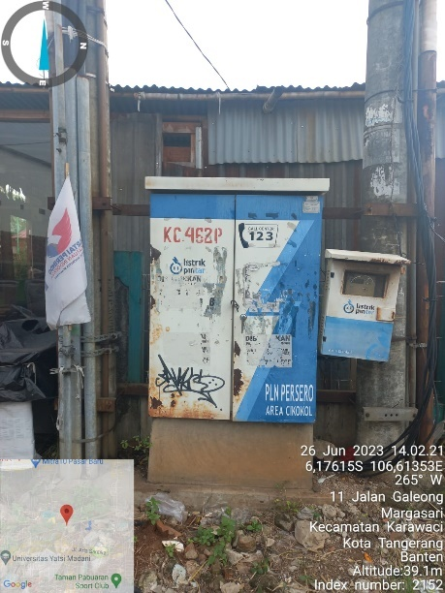
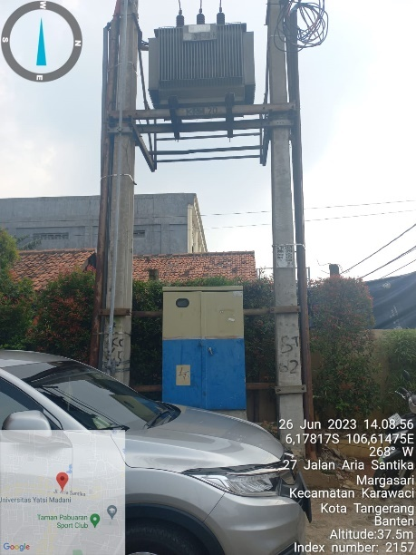 | 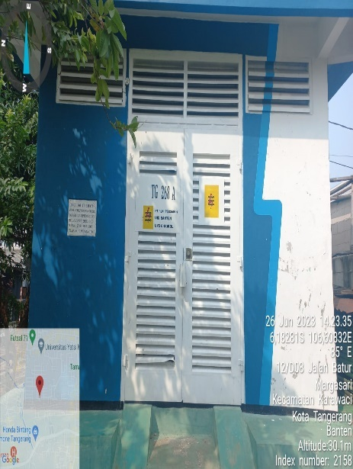 | 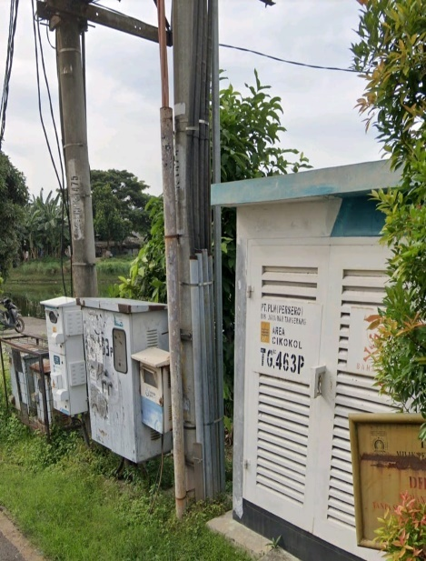 | 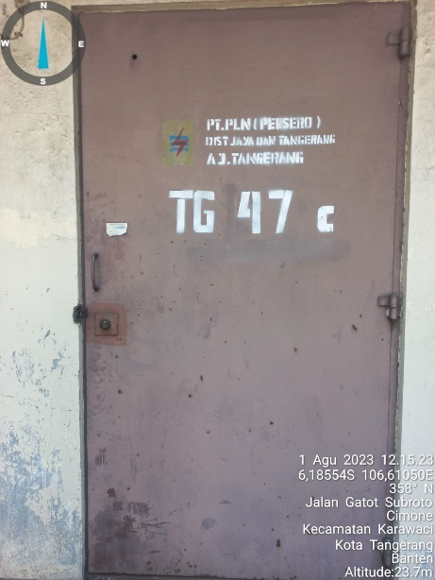
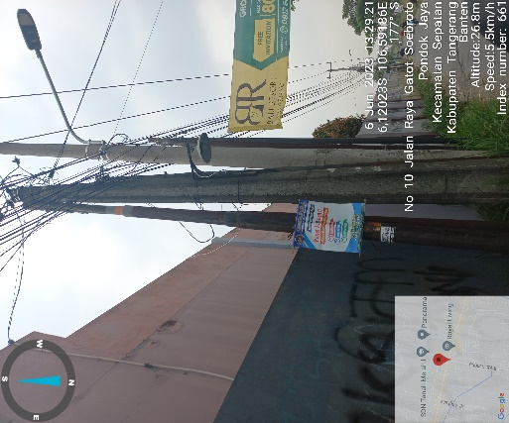
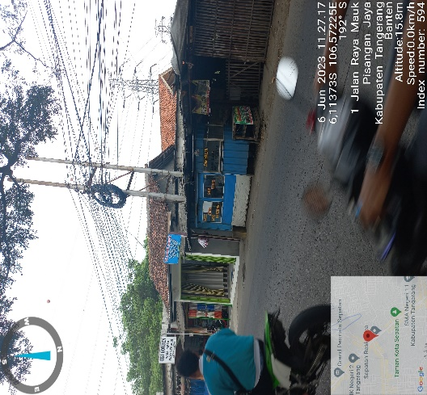
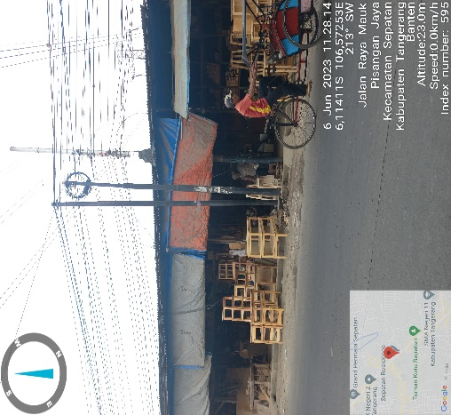

BUS 4

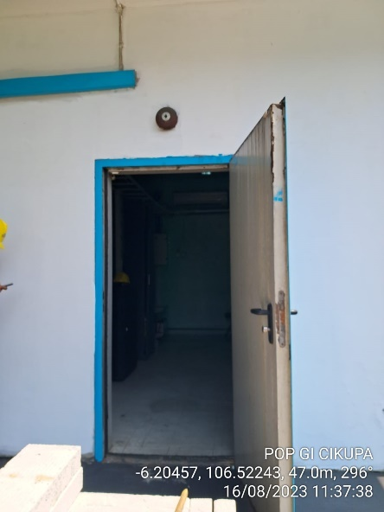 |  | 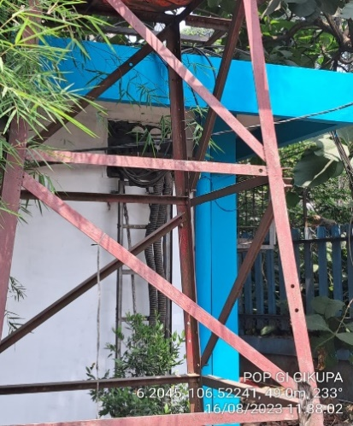 | 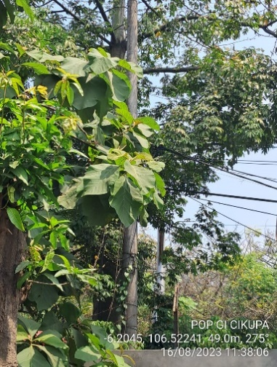
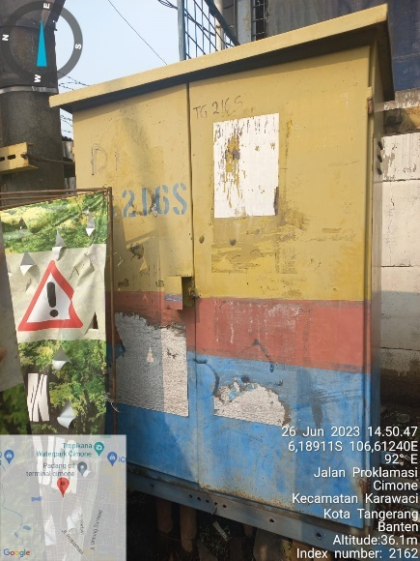 | 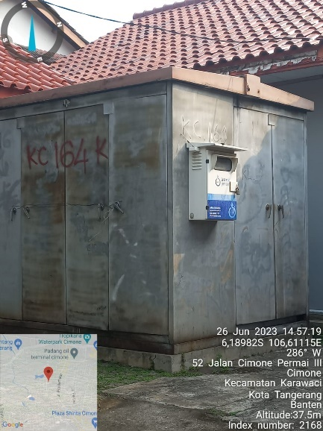 | 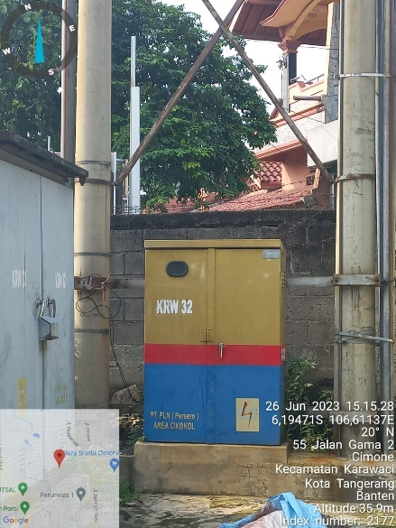 | 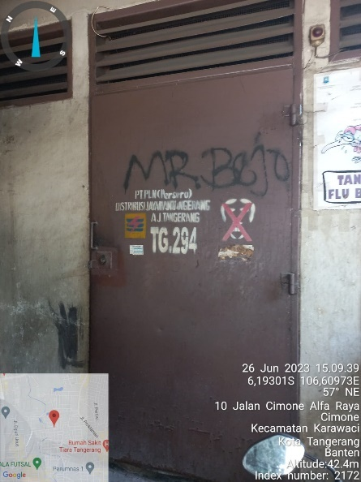

Tikor Propose New Pole Segemen 1
S6 10.083 E106 37.935
S6 10.080 E106 37.943
S6 10.076 E106 37.957
S6 10.085 E106 37.964
Tikor Propose New Pole Segemen 2
S6 09.152 E106 38.691
S6 09.171 E106 38.696

BUS 1

POP_1TGR10004_KUTABUMI PS KEMIS MINI POP
S6 09.187 E106 34.176

NEW JB
S6 09.211 E106 34.025

NEW JB
S6 09.138 E106 35.743

NEW JB
S6 10.180 E106 36.053

NEW JB
S6 10.437 E106 36.737
GH TG 292
S6 11.518 E106 36.872
GH KRW 9
S6 11.546 E106 36.774
GH KC 291
S6 11.612 E106 36.983
GH KRW 38
S6 11.322 E106 37.148

NEW JB DCU
S6 10.931 E106 36.366

NEW JB DCU
S6 11.131 E106 36.639

NEW JB DUC
S6 10.963 E106 36.497

NEW JB DCU
S6 10.550 E106 36.805

NEW JB DCU
S6 10.686 E106 36.871

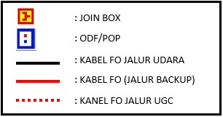

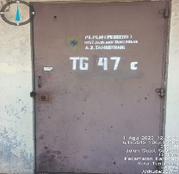
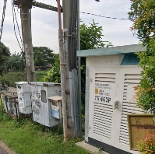
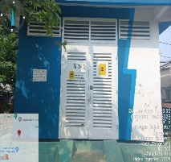
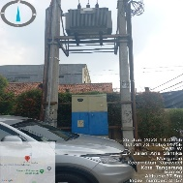
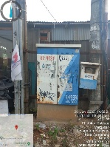
DIAGRAM SCHEME RING 8 – BUS 9

GARDU TG268A
S6 10.971 E106 36.498

GARDU KC463P
S6 10.923 E106 36.370
GARDU KC462P
S6 10.567 E106 36.803

GARDU KRW20
S6 10.692 E106 36.885

GARDU TG47C
S6 11.127 E106 36.642

BUS 4
DIAGRAM SCHEME RING 8 – BUS 16

GARDU TG294
S6 11.581 E106 36.584

GARDU KC164K
S6 11.386 E106 36.665
GARDU TG216S
S6 11.348 E106 36.750

GARDU KRW32
S6 11.683 E106 36.682

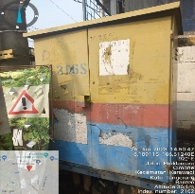
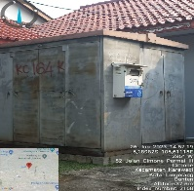
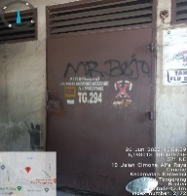
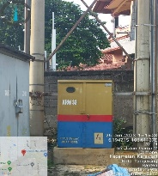

NEW JB DCU
S6 11.687 E106 36.677

NEW JB DCU
S6 11.586 E106 36.584

NEW JB DCU
S6 11.382 E106 36.665

NEW JB DCU
S6 11.344 E106 36.746

NEW JB
S6 11.317 E106 32.439

POP_1TGR005 CIKUPA GI SHELTER PLN
S6 12.280 E106 31.347

NEW JB
S6 11.316 E106 35.982

NEW JB
S6 11.869 E106 34.196

NEW JB
S6 11.029 E106 31.742

NEW JB
S6 11.795 E106 31.623

