Lampiran

Dokumentasi Penelitian:

Penerapan Metode *Design Thinking* dalam Perancangan *User Interface* (UI) dan *User Experience* (UX) Aplikasi Wawancara Daring Narasource

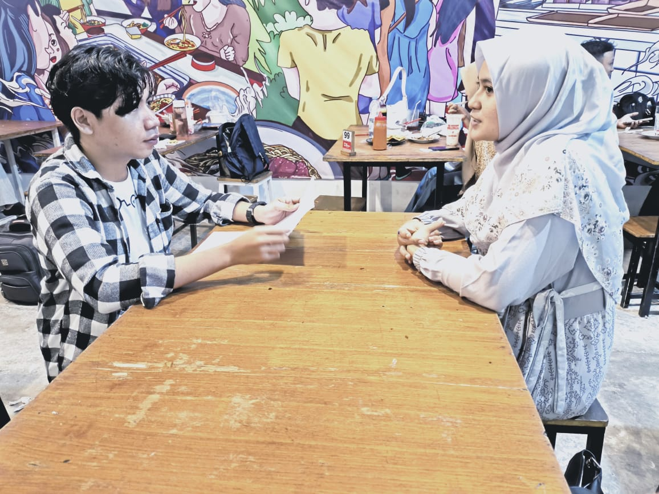

Wawancara Responden 1

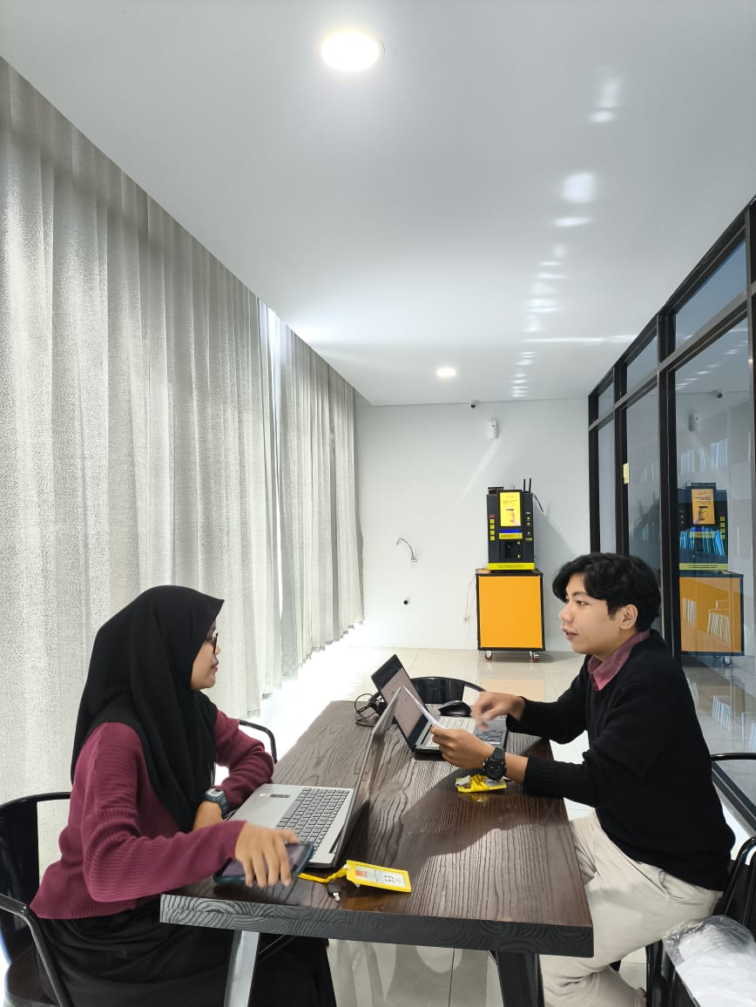

Wawancara Responden 2

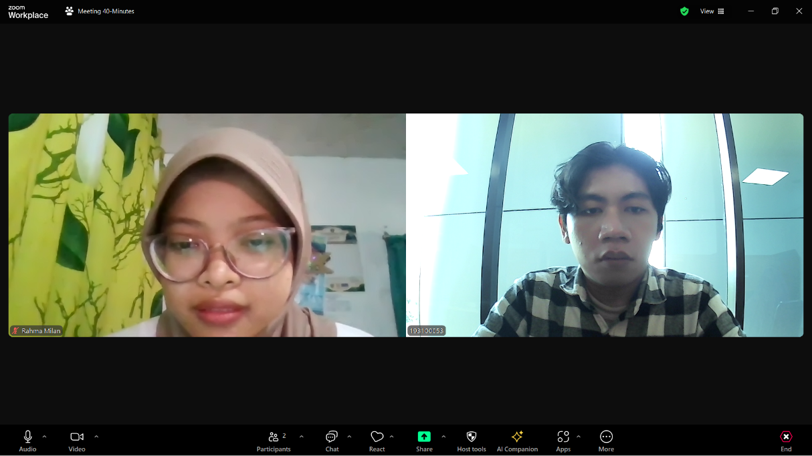

Wawancara Responden 3

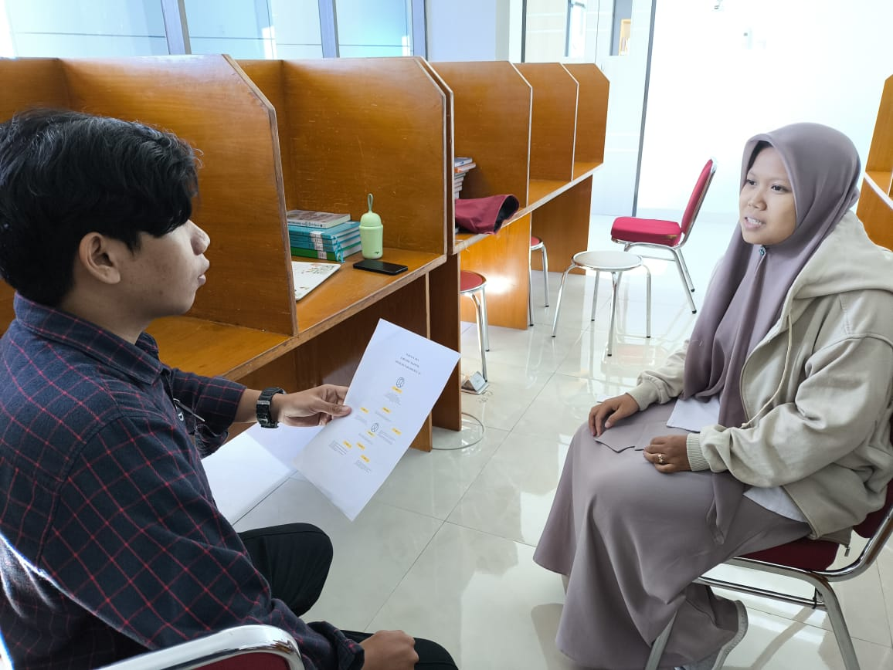

Wawancara Responden 4

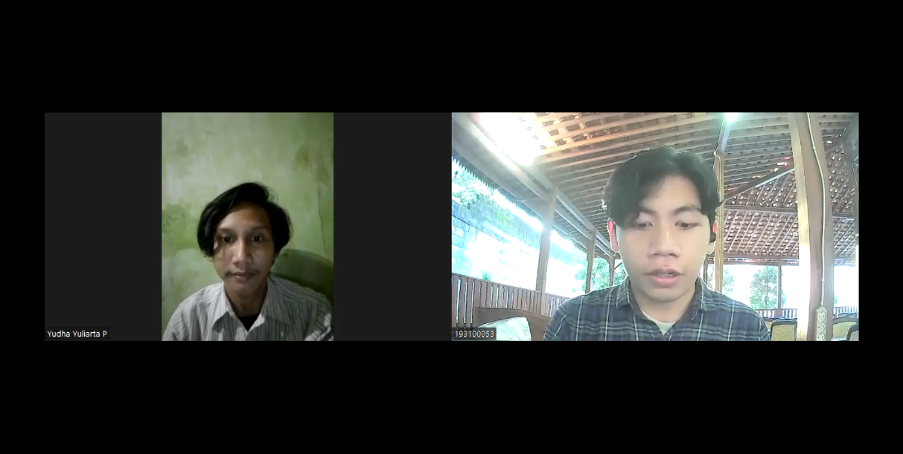

Wawancara Responden 5

Lampiran 1.7 Dokumentasi *Testing* Pengguna

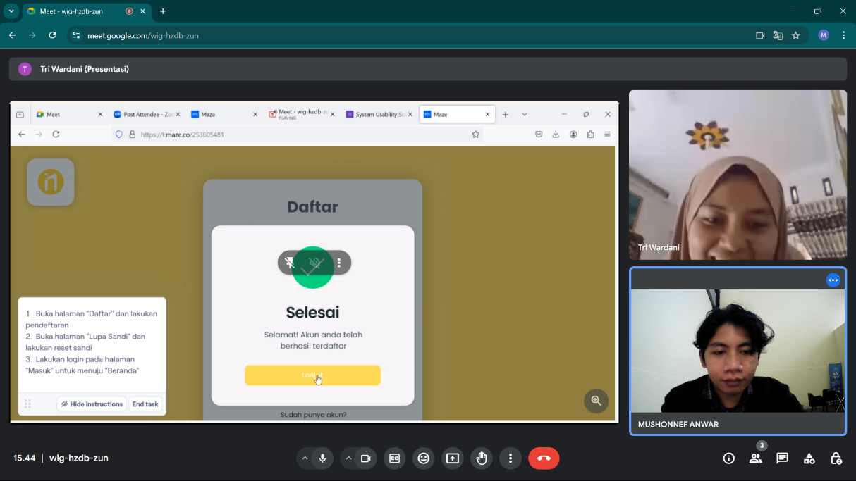

*Usability Testing* Responden 1

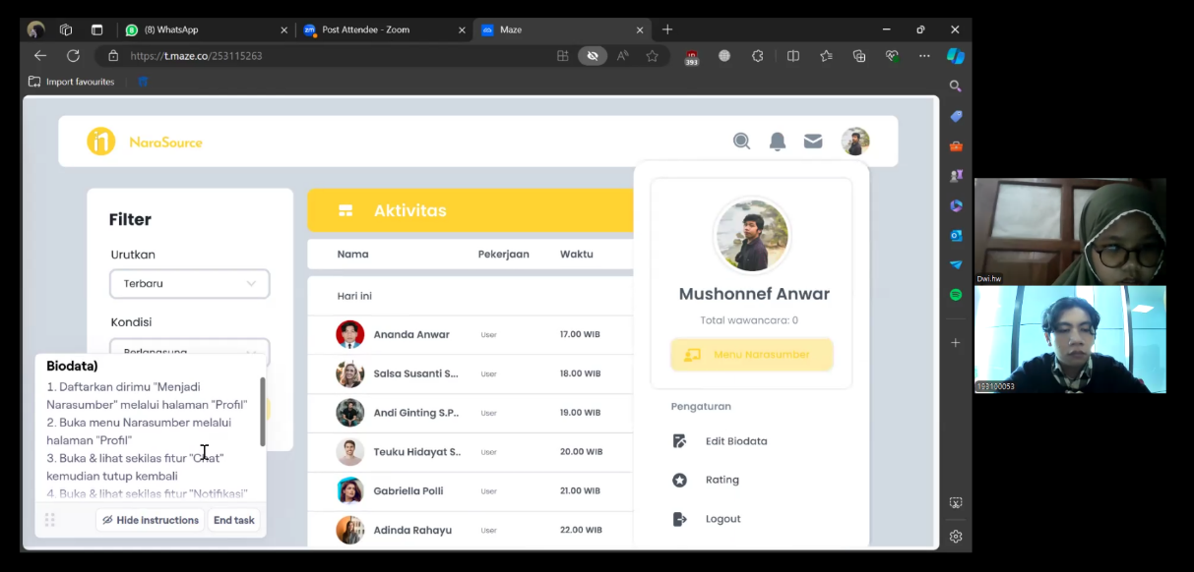

*Usability Testing* Responden 2

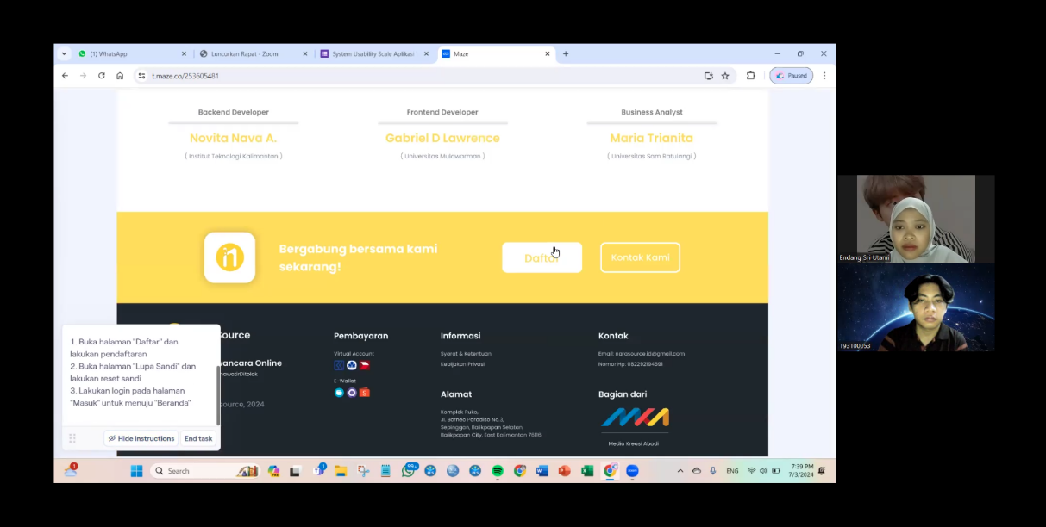

*Usability Testing* Responden 3

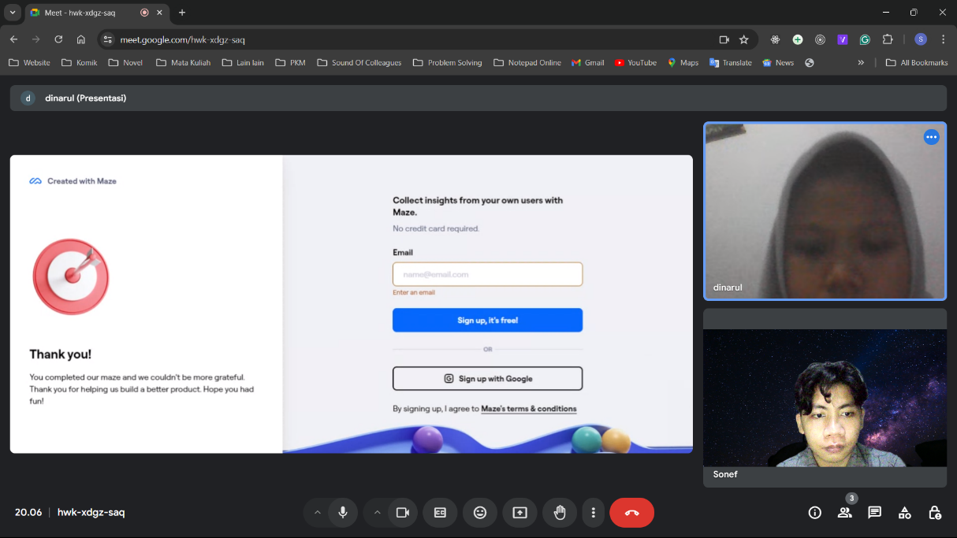

*Usability Testing* Responden 4

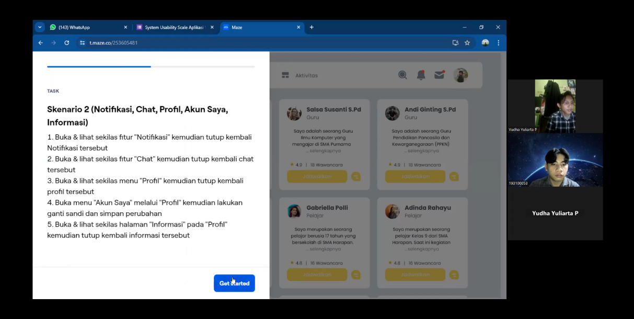

*Usability Testing* Responden 5

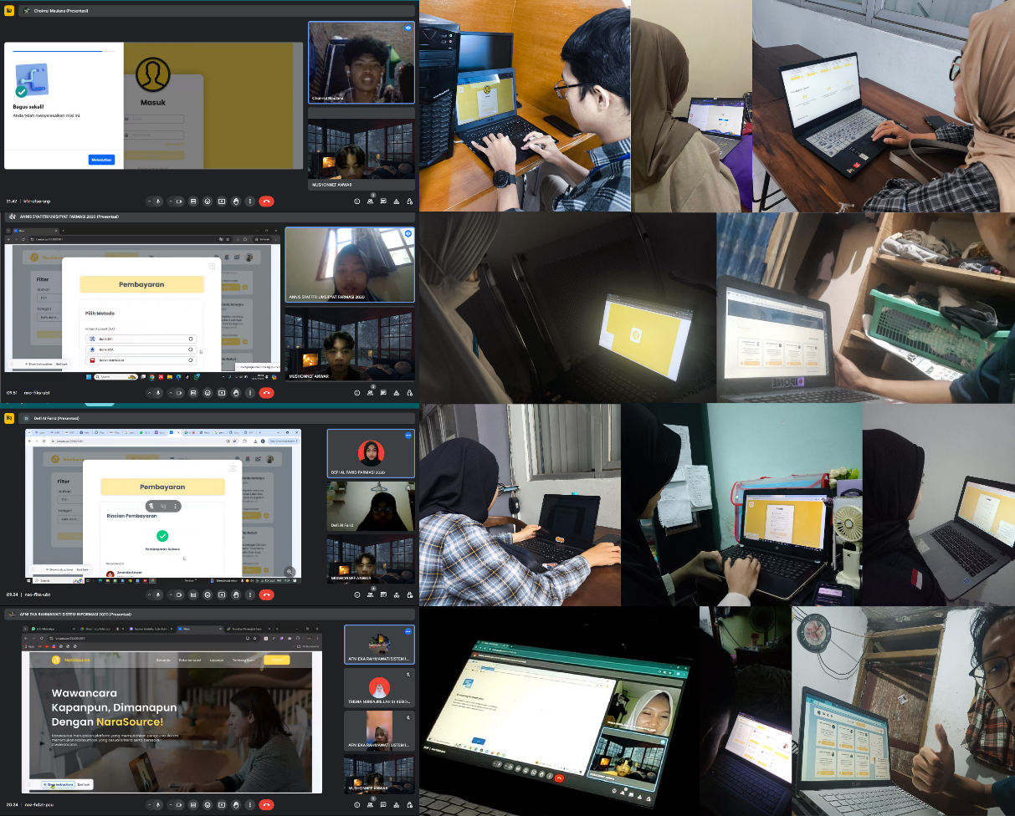

*Usability Testing* Responden 6 – 20